Networking Exercises:

1. **Use a socket connection to allow a client to specify a filename of a text file and have the server send the contents of the file or indicate that the file does not exist.**
2. **Modify Exercise 1 to allow the client to modify the contents of the file and send the file back to the server for storage. The user can edit the file in a JTextArea, then click a save changes button to send the file back to the server.**
3. ***(Multithreaded Server)*** Multithreaded servers are quite popular today, especially because of the increasing use of multi-core servers. Then use several client applications and have each of them connect to the server simultaneously. Use an ArrayList to store the client threads. ArrayList provides several methods to use in this exercise. Method size determines the number of elements in an ArrayList. Method get returns the element in the location specified by its argument. Method add places its argument at the end of the ArrayList. Method remove deletes its argument from the ArrayList.
4. ***(Checkers Game)*** Develop a checkers program modeled after the Tic-Tac-Toe program. The two users should alternate making moves. Your program should mediate the players’ moves, determining whose turn it is and allowing only valid moves. The players themselves will determine when the game is over.
5. ***(Blackjack Game)*** Develop a blackjack card game program in which the server application deals cards to each of the clients. The server should deal additional cards (per the rules of the game) to each player as requested.
6. ***(Poker Game)*** Develop a poker game in which the server application deals cards to each client. The server should deal additional cards (per the rules of the game) to each player as requested.
7. ***(Networked Morse Code)*** Perhaps the most famous of all coding schemes is the Morse code, developed by Samuel Morse in 1832 for use with the telegraph system. The Morse code assigns a series of dots and dashes to each letter of the alphabet, each digit, and a few special characters (e.g., period, comma, colon and semicolon). In sound-oriented systems, the dot represents a short sound and the dash a long sound. Other representations of dots and dashes are used with light-oriented systems and signal-flag systems. Separation between words is indicated by a space or, simply, the absence of a dot or dash. In a sound-oriented system, a space is indicated by a short time during which no sound is transmitted. The international version of the Morse code appears in the following table:

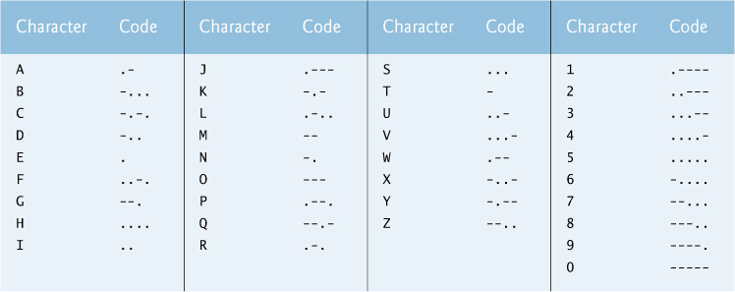

Write a client/server application in which two clients can send Morse-code messages to each other through a multithreaded server application. The client application should allow the user to type English-language phrases in a JTextArea. When the user sends the message, the client application encodes the text into Morse code and sends the coded message through the server to the other client. Use one blank between each Morse-coded letter and three blanks between each Morse-coded word. When messages are received, they should be decoded and displayed as normal characters and as Morse code. The client should have one JTextField for typing and one JTextArea for displaying the other client’s messages.